**City Year Chicago Team Placement Results, School Year 2018**

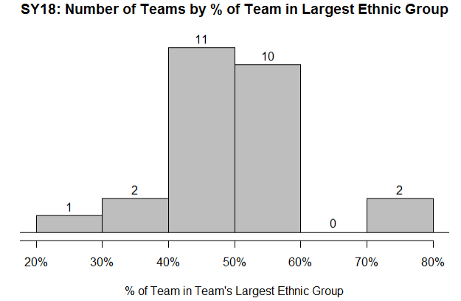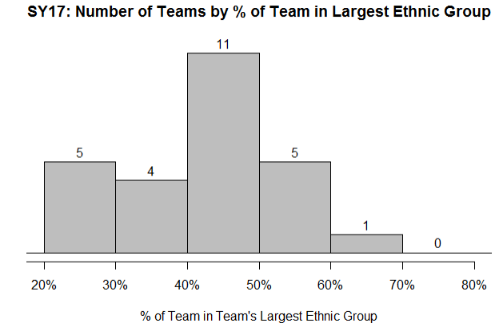

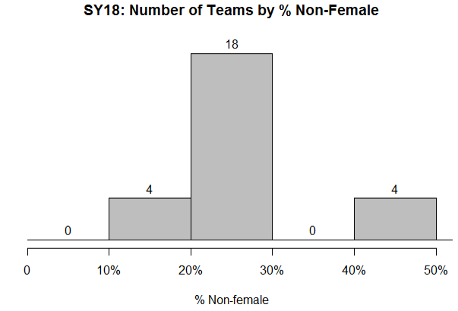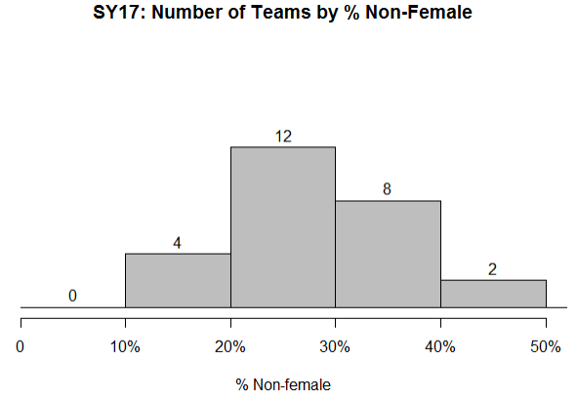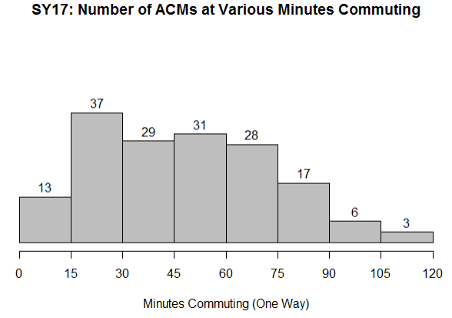

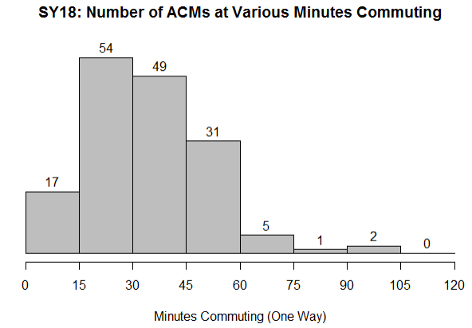

**Projections**

The whole corps will save **114 hours** of commuting per in-school service day.

Over the course of a service year (150 in-school service days in SY17), the average ACM will save **90 hours**.